Smart Healthcare Systems for Elderly People Using Industry 4.0

**Abstract**

The Internet of Things (IOT) is essential for innovative applications such as smart homes, healthcare, education, Government departments, Municipal corporations etc. IOT applications are particularly useful for health care monitoring of elderly people. Increasing elderly population presents a major challenge to healthcare systems worldwide. Healthcare technologies like IoMT, AI and wearables have surged to claim personal health management as one of the emerging solution areas in contrast. They allow for continuous monitoring, chronic disease management and improved safety among older adults. In this chapter, we discuss the combination of these technologies to enhance the life and care of older adult populations. This chapter mainly strategies about the recent trends for smart home healthcare systems for senior citizens. This chapter discusses different types of the IOT based health monitoring system for elderly people. Combining technology with medical care, these systems allow elders to receive the follow-up the necessary medical supervision without leaving their own home and familiar environment. One of the key benefits of smart home healthcare systems to seniors is the independence that it brings them. Challenges and open issues in health care monitoring systems as well as security are elaborately explained. Lastly, we list suggestions and future direction of research.

**1.** **Introduction**

#### **1.1. Background**

As the number of elderly people globally keeps rising, it becomes an issue because they have special needs in terms of health care. They need treatment for chronic diseases, mobility issues and even cognitive reduction. The transformation of health practices is being driven by the means of Industry 4.0 environment like robotics, AI, IoT and big data resulting in intelligent, efficient and customized treatment procedures for optimum healthcare solutions. These technologies enable remote care, enhance diagnostic techniques and augment medical monitoring through devices such as wearables, smart homes and telemedicine. This ultimately decreases total healthcare costs while also promoting increased quality of life for older adults. Every industry has its own share of challenges and opportunities, and health care is no exception; in fact, the first-time lock- Factors such as Industry 4.0, which comprises cutting-edge technology tools like IoT, AI big data analytics cloud computing into medical systems contact us have taken up by manufacture to revolutionize it altogether. These can lead to the development of smart, interconnected systems which ensure quality targeted, preventive and predictive health care. It is using AI to analyse the real-time health data collected from these IoT devices and this in turn helps with creating personalized treatment plans which ultimately assists in diagnosis and intervention at the earliest. Cloud computing increases productivity, reduces human error and enhances patient outcomes by providing secure remote access to medical data and services. Together, these developments enhance patient care and healthcare delivery. Among the various attributes of an IoT-based system, energy consumption of wireless sensor network (WSN) is a major concern. A very important point of BAN insertion is the power consumption tracking of these sensors since it would cause a huge hesitation if the limited available energy source for that sensor is consumed. Sensors going out of power while monitoring a patient at risk is completely unacceptable. In order to face this problem, they have proposed an energy efficiency algorithm which is are called Energy Efficient ON-OFF algorithm which can be used for sending medical data from sensors to gateway nodes. The paper is contributed by them who also did analysis of energy dissipation on the sensor end as well using EEOOA show again its superiority over traditional techniques[1].

#### **1.2. Importance of Smart Healthcare for the Elderly**

Oldsters are faced with mobility challenges, semi–cognitive deterioration, and chronic ailments. The traditional model of healthcare is unable to cater the rising demands hence creating interest in smart healthcare systems, which use advanced technology such as IoT, AI and robots. These systems employ assistive devices, artificial intelligence-assisting diagnostics, and patient monitoring technologies to deliver anticipatory, continuous, and personalized care. Smart healthcare improves the overall quality of life for senior citizens, encouraging independence, easing burden on caregivers, and bettering health management amongst geriatric patients.

According to experts, digital healthcare systems functioning in Internet of Things (IoT) environments can provide ideal solutions for some of the most pressing healthcare concerns. Usually, remote health monitoring architectures take the form of three-layer structures: an analysis layer that extracts knowledge from data to ensure timely medical treatment; a transmission layer for securely transferring the data collected; and a data collection layer with sensors used to monitor vital signs. Such a multi-faceted campaign advances virtual life and surveillance, both of which are critical for improving health outcomes in the elderly population. With the application of Industry 4.0, smart healthcare solutions can be used in remote medical treatment, live monitoring of health data, and better engagement among patients. Leverage advanced technologies (IoT devices, data analytics, artificial intelligence) while facilitating a remote connection between patients and caregivers to monitor vital signs and chronic illnesses as well as form personalized treatment plans. With continuous monitoring and individualized treatments possible, smart healthcare allows the elderly to live their best quality of life by being more independent and taking a proactive approach towards health.

**2. Industry 4.0 in healthcare**

**2.1. Overview of Industry 4****.0**

Health technology also includes pharmaceutical products, biologicals, and diagnostic tools and devices; as well as methods for prevention of diseases; including grove techniques, systems designed to provide health care services more efficiently; social support systems or procedures for assessing effectiveness in the capitalization process. This notion has gained in importance over the last thirty years with a dramatic growth of studies published in this field. As the volume of health technology literature increases at an exponential rate, evaluating such publications is imperative. Moreover, the effectiveness of using the proposed EEOOA algorithm in sensor applications outperforms existing methods[2].

Industry 4.0 is leading the transformation of healthcare with its focus on convergence of advanced health technologies including but not limited to artificial intelligence (AI), Internet-of-Things (IoT)-enabled sensors, robots and big data analytics. This combination of technologies provides "smart healthcare," meaning that health interventions are more effective, predictive and personalized[3]. A key component of this progression is health technology, which includes prescription drugs, medical equipment, diagnostic methods, and organized systems for diagnosis, prevention, and rehabilitation. This tendency is reflected in the growth of health technology literature, and in order to fully realize the potential advantages of these new technologies, rigorous assessments are necessary[4].

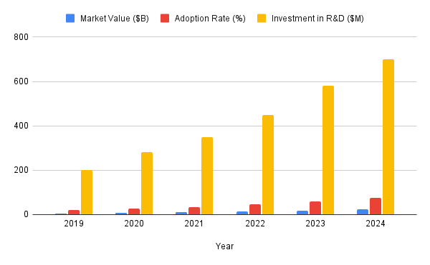

**Fig1:** Industry 4.0 over the years from 2019 to 2024

Three important metrics—market value (in billions of dollars), adoption rate (in percentage), and R&D investment (in millions of dollars)—are shown in the graph as they change from 2019 to 2024.

**Market Value:** Over the course of the period, the market value has clearly increased. It rises progressively each year after beginning at a comparatively low point in 2019. This indicates that the product or service being represented is becoming more and more accepted by the market. Over the course of the period, the graph clearly demonstrates an increase in Market Value. It rises progressively each year after beginning at a comparatively low point in 2019. This indicates that the product or service being represented is becoming more and more accepted by the market.

**Rate of Adoption:** Although it is not as noticeable as the Market Value, the Adoption Rate likewise exhibits a positive trajectory. It appears it is a base which remains sure and continuously growing from 2019 to 2023, which means more people are using the product or service. The Adoption Rate, while perhaps less visible than the Market Value, also shows an upward trend. Shows a consistent upward trend from 2019 to 2023, meaning more and more users are consuming the product or service.

**Research & Development investment:** Fourth is the R&D investment, which goes on a more stable upward slope. In 2019, it starts at a low level and in 2024, the increase is significant. This may mean an intentional decision to increase the investment into R&D. The cost of Research and Development displays a more stable increasing curve. 2019 sees it begin at a moderate level, while 2024 sees a notable uptick. This would indicate a calculated move to increase funding for R&D, perhaps with the goal of spurring additional innovation and expansion.

The technologies associated with Industry 4.0 in healthcare are making significant strides in the areas of rehabilitation and patient assistance. From implementing robotics powered by real-time data and smart algorithms for both patient rehabilitation and surgical treatment using targeted, minimally invasive procedures that optimize recovery times[5]. In addition, wearables and non-wearable sensors installed within the patients home become more advanced to continuously measure health metrics which paves pathways towards remote care as well tailored personalized treatment.

**2.2. Key technologies in Industry 4.0 for healthcare**

**2.2.1. Internet of Things (IoT)**

Industry 4.0 is based on IoT, as it provides respective systems of intelligence and makes the networked control system such as smart home and healthcare possible. Comprising connected digital devices that collect, share and analyse data for automating processes and making decisions in real-time, the Internet of Things (IoT) is an industry 4.0 innovation enabler. The IoT have potential to change the older healthcare by remote monitoring, predictive analysis, and adaptive environments that can enable people to maintaining their health and quality of life without interrupting their daily routines[6].

This study recommends non-wearable sleep sensors for seniors, which aligns with the objectives of Industry 4.0, such as enhanced continuous inconspicuous monitoring through IoT devices[7]. The sensors are nonintrusive and measure physiological data, such as heart rate, respiration and movement without the wearables. This type of IoT integration allows care providers or health care professionals access to data from these sensors and can be automatically analysed, thus improving the standard-of-care for geriatrics as well as fostering their independence. Those IoT devices are designed with user-centred Industry 4.0 concepts to promote seamless, comfortable, and unobtrusive technological usage—achieving minimum disturbance in the person activity of daily living and sleep. Furthers the significance of usability and easiness in IoT design by changeability of batteries and location factors like sensors for visual display etc. The pervasive nature of Industry 4.0 with multiple IoT devices interacting would necessitate a simple and conducive design that alleviates complexity and fosters user trust with the presence also noted to harness in systems mainly due to usability (c.f., [9]). When information given to the elderly and those who care for them is in an easily understandable form, the needed health-related information can be accessed promptly[8]. It increases efficiency of the system and reduces barriers to use.

Additionally, accessibility in making sensor repairs and follow-up services easy is also in line with a key focus of Industry 4.0, which is reliability[9]. Smart home devices create a cycle of feedback, maintenance and improvement that reinforces sustainability and reliability over time. This approach is directly aligned with the industry 4.0 vision of building modular, intelligent and adaptable systems that respond in real-time to dynamic process conditions, ultimately increasing safety and optimizing resource utilization in interconnected environments.

**2.2.2. Artificial Intelligence (AI)**

Notice that in this Industry 4.0 era, artificial intelligence (AI) has the pivotal role in leading to the next revolution of change between every industry that is more on effective for various applications including even biomedical [1]. Industry 4.0 involves the integration of advanced technologies like AI, IoT, big data and robotics into manufacturing & service operations to create autonomous systems that are interconnected (cyber-physical), self-optimizing and extremely resource-efficient. The ability of AI to process huge amounts of data, perform complex analytical functions, and operate autonomously are in line with the objectives of Industry 4.0 wherein real-time data-based decision making and extreme productive outcomes are a priority[10].

This recalls several defining features around values of interest like fairness, explainability, accountability and reliability when it comes to the role of AI in the biomedical sector (in line with Industry 4.0 [39]). For example, in healthcare, AI is used for example in drug discovery where all the relevant biological data manipulation tools are involved in machine learning techniques that scan, they complex biological systems and quickly find potential candidates. AI solutions can improve diagnostic accuracy during guided surgeries, provide treatment strategy input from advanced imaging to minimize errors and ensure better outcomes. This is similar to the focus on precision and prediction in manufacturing and supply chain management from Industry 4.0, in which AI systems forecast demand and predict maintenance, while minimizing waste[11].

The utilization of high-level algorithms that can emulate human functions, such as logical reasoning, predicting outcomes based on historical data or knowledge-based learning also reinforces the relevance of AI in Industry 4.0 as well[12]. This is where AI capabilities of leveraging data to make decisions that forecast patterns and detect outliers drive the idea of the industry 4.0 "smart" factory, in which systems can adjust automatically in real time. Implementing explainable and accountable AI systems will ensure that the decision-making processes in these intelligent systems are transparent and reliable, establishing trust among users and stakeholders, which is critical to gain acceptance of Industry 4.0 technologies.

**2.3. Robotics and Automation in Elderly Care**

Robotic systems are increasingly used in elderly care to assist with mobility, medication administration, and cognitive therapy. Robots powered by AI algorithms can aid in rehabilitation exercises, monitor patient movements, and even provide companionship​. Robotic caregivers help alleviate the strain on human caregivers, offering reliable and consistent support to elderly individuals.

Exoskeletons like the Laevo and surgical robots with artificial intelligence (AI) capabilities represent a developing nexus between technology and healthcare, both aiming to improve human skills in physically demanding activities[13]. AI-assisted movement surgical bots provide real-time data analysis, predictive insights and can also assist in performing sophisticated surgery accurately, thereby improving decision making forms of recommendations to medical personnel minimizing effort exerted by the human side during difficult procedures. Exoskeletons like the Laevo provide individualized lower back support when bending and lifting repeatedly, alleviating pain by supporting the body and improving factory worker productivity in heavy working environments. Both technologies seek to improve results and reduce physical strain in order to maximize human performance, whether in industrial or surgical settings. As artificial intelligence (AI) rapidly expands the autonomy of surgical robots, exoskeletons such as the Laevo FLEX are improving ergonomics to better support the endurance and mobility of workers. Even with these developments, strict regulation is still necessary to guarantee both fields' efficacy and safety as they develop further[14].

Elderly people often prefer to reside in their own homes because it gives them a feeling of familiarity, independence, self-assurance, and satisfaction from taking care of themselves, which they often favour over receiving assistance in adult day care centres, long-term care facilities, or nursing homes. This preference can be heavy to make but robotics and automation can do wonders in making this preference a reality! To meet these specific needs of elderly persons, we can develop a home care model by integrating smart platforms for robotic nursing and sensor networks. They provide context-based, ubiquitous computing applications and home automation services that not only enable older people to perform their daily activities but also support independent living without needing anyone to leave their home. This will both stimulate their independence and also ensure that they have access to reliable care that meets their evolving needs[15].

**3. Applications of Smart Healthcare for Elderly People**

**3.1. Remote Patient Monitoring**

**3.1.1. Wearable Devices**

It is through these devices that the monitoring of elderly care, or remote patient monitoring (RPM) for the elderly is done, which focuses on vital health stats as well[16]. The device sensors on items like smartwatches, fitness trackers and specialized medical wearables can constantly measure health indicators and ship that timely data to healthcare providers for quick alerts. These technologies are befitting solutions for the management of chronic diseases, like cardiovascular disease and diabetes to name a few age-associated health problems[17].

Wearable devices now keep track of a limitless number of physiological parameters 24 hs/day, HR (heart rate), ECG, SPO2 blood oxygen levels and physical activity. These are connected and sensor data collected from these edges will be streamed to IoT platforms which provide health status of the patient. Tracking for conditions like atrial fibrillation and abnormal heart rhythms done in elderly people has been one of the most important use cases enabled by the wearable ecosystem[18].

According to the research conducted in 2024, the use of ECG-capable smartwatches “can reduce emergency hospital visits with an early detection of irregular heartbeats” ​e Study Evidence**: The study examined by JMIR Cancer states that wearable sensors were used to observe the physical exercises and sleep durations of aged cancer survivors and generate creative results about post-surgery recuperation[19]. Another similar examination presented in Frontiers in Public Health in 2023 demonstrated wearable sensors’ advantages in permitting self-care among elderly people and improving their remote athletic observations[20]. Thus, wearable devices can send early warnings of potential issues[21], [22].

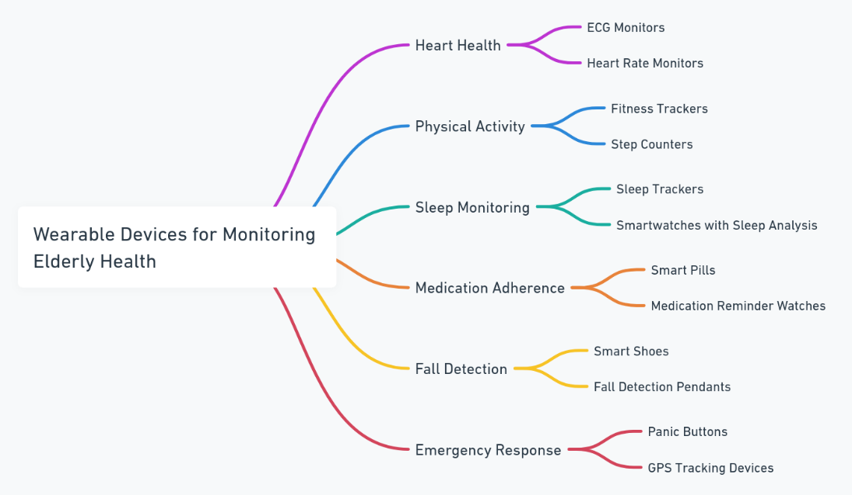

**Fig2:** Various wearable devices for monitoring elderly health

**3.1.2. Smart Home Sensors**

Smart home sensors can help to provide a safer living environment for the elderly in performing daily activities especially detecting falls, monitoring movements and tracking medication adherence. Living independently — sensors connected via the internet of things (IoT) join seniors to receive continuous medical supervision, enhancing safety and security at home[23].

We have made significant advancements in being able to predict falls using smart home sensors (accelerometers, infrared cameras and pressure sensitive floor mats) that detect aberrant motions. When a fall is detected, these systems can automatically inform caregivers or send for emergency services to act fast[24]. A retrospective cohort study conducted in 2023 showed that these types of sensors can decrease the likelihood of fall-related severe injury by up to 30%. —Movement Monitoring**: Motion tracking sensors located throughout an elderly resident's home keep abreast patterns[25]. Such systems can, for example, alert relatives when abnormal deviations in patterns are observed like extended periods of rest or wandering at night which could indicate that the health condition is getting worse with possibly a quicker decline to future assistance and care needed due mobility impairment / walking disability in daily life situation but also possible adjustments mental state challenges. Clever pill dispensers - Internet of Things arrangements that keep patients advised to take their pills and log whether or not somebody opened the pill stacks mag they represent provided assurance of a notable help with adherence to restorative regimens, which is significant when treating unwelcome states regular in senior phrases.

**3.2. Telemedicine and Telehealth**

Definitely, the incorporation of telemedicine platforms has genuinely changed conveying healthcare to seniors because it is less intrusive i.e. fewer hospital visits. Telemedicine can not only help in better management but also is the best tool to cut down on costs, as they are able to seek assistance at their home itself for some health issues. This also helps ensure that patients will be able to continue seeing their provider, which is especially important in light of COVID-19 transmission risk mitigation practices.

**3.2.1 AI Chatbots and Virtual Assistants**

Many such services are driven on AI and it tends to bring a lot of value by using Chatbots and virtual assistants in telehealth. A few of these tools supports a range of services from medication reminders to answering basic medical questions and providing conversational AI for mental health. As an example, Amazon Alexa or Google Assistant can be trained to serve as virtual assistants and refer you elderly folks for medications reminders throughout the day to exercise daily work out appointments.

A 2024 study in the Journal of Medical Internet Research discovered that elderly patients could be up to 20 % more likely to adhere to their medication if they used AI-powered virtual assistants. Virtual assistants are used to remind both the patient and caregivers if a dose is not taken, which in case of medications related to chronic conditions can help take timely medication. Ai chatbots are a simple way to offer mental health resources, holding conversations that engage the end user in conversation and reducing their loneliness. This is particularly relevant as physical health and mental well-being are inter-related in aging populations​.

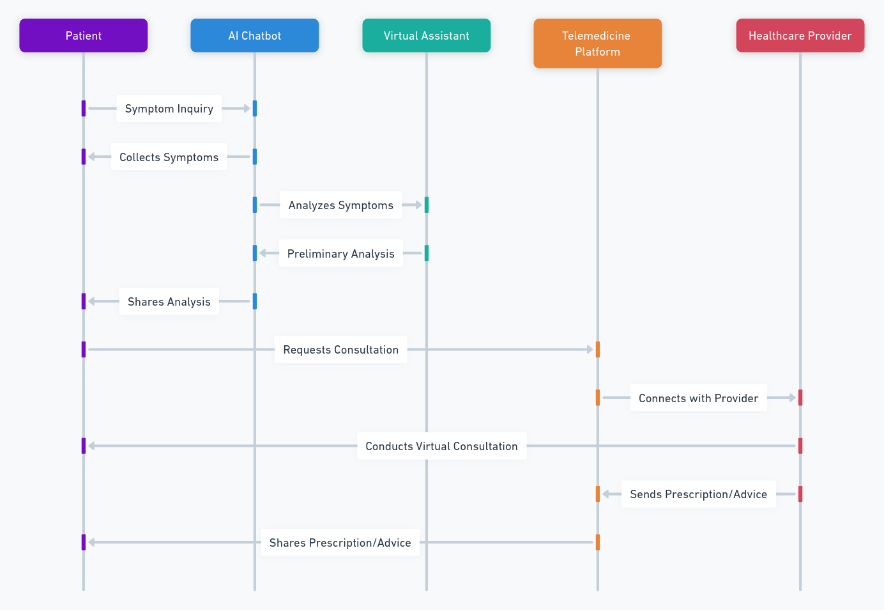

**Fig3**:Diagram of Telemedicine and Virtual Care

Diagram illustrating the interaction between patients, AI chatbots, virtual assistants, and healthcare providers through telemedicine platforms.

* 1. **AI-Powered Diagnostics and Predictive Analytics**

Healthcare diagnostics have undergone a sea-change with the advent and rise of Artificial Intelligence (AI), more particularly in assessing neurodegenerative diseases such as Alzheimer's. With machine learning analyzing scarce and complicated datasets from MRI scans, genetic data, cognitive assessments, AI models can detect early signs of brain changes that are more likely to be associated with the presence of Alzheimer's. A 2024 study in IEEE showed that AI MRI analysis delivered higher accuracy when it comes to detecting early onset of Alzheimer's, able to predict the disease up t0 five years prior its signs became apparent. This ability to detect early facilitates appropriate and timely interventions, reducing the severity of disease progression so that patient survival is enhanced[26].

Models based on AI can also distinguish between different stages of Alzheimer's, with more personalized treatment plans as a result. A 2024 study in AI and Neuro-Degenerative Diseases observes that these models review patterns across multiple modalities of data (such as brain imaging combined with biomarkers), often containing discriminatory information not caught by human clinicians. Through big data analytics, it would come to understand even tiny variations in patient behaviour (like changes to speech patterns or movement that might offer clues of cognitive decline, for example) -- subscribe to them. This insight into disease progression has also enabled the elucidation of care regimens for treatment, improving standards and quality of life within Alzheimer's[27].

**4. Benefits and Challenges of Implementing Smart Healthcare for the Elderly**

Recently, the method used for providing services to elderly population has been to assist care delivery through smart healthcare system that uses Industry 4.0 technologies like IoT, AI and big data analytics. There are many advantages of these systems, such as enhancing patient quality-of-life and reducing healthcare costs but there are also barriers concerning technology adoption and acceptance.

**4.1. Benefits**

**4.1.1 Enhanced Quality of Life**

Cloud based systems integrating Smart healthcare systems; specifically, IoT enabled has flown elderly life on daily basis. These systems provide timely and accurate medical assistance, which ensures day to day monitoring of the elderly population so that age-related ailments can be dealt with better. At least some chronic disease, whether diabetes or hypertension or coronary artery disease will be present in most older people to variable degrees that need a combination of careful and frequent monitoring and adjustments. Traditional healthcare systems do not provide continuous monitoring and instead respond when required only during health emergencies a little too late. On the other hand, IoT based devices like wearable for health-related alerts such as pulse rate, blood pressure and glucose level etc., bridge this gap through live tracking. They plug into the healthcare system, using real time data that feeds telemedicine type services that notify providers when something is out of whack. This ability helps to shorten the duration of identification of health issues, from prognosis and care[28].

A separate study published in Sensors (2023) identifies the response time reduction for elderly patients when IoT enabled devices are involved during emergencies. In fact, the research even found that use of these devices could reduce medical emergency response times by up to 40 percent, which shortens precious minutes in situations where time is critical for survival like stroke or heart attack. Over Smart and secured healthcare systems also allow distant patient monitoring which will again let aged people stay at home. It may also minimize the need to see hospitals often, which supports households with elderly persons as they drive security and freedom into their lives every day[29].

**4.1.2 Cost-Effective Care**

Smart healthcare systems – Can help to reduce the costs of healthcare with AI, IoT and telemedicine being able to make a great impact in this field. These tools are able to power teleconsultation and patient continuous monitoring, hence eliminating the need for physical visits or hospital stays. This change provides elderly patients with convenience while reducing healthcare infrastructure burdens by improving the efficiency and decrease in cost of care delivery[30]. They also have the potential to be expensive for both patients and providers, considering that dispensing medications or physical appointments would likely demand higher resources than a digitized health monitoring program.

Take AI-powered telemedicine platforms for instance, which allow consumers to field a consultation with doctors over video call and through digital health records so that the patient no longer needs to go into the clinic. Particularly helpful for albeit but immobile older patients, who have trouble visiting hospitals and those from disadvantaged rural areas far removed from medical facilities! They usually cost less than visiting in a clinic. And these save on the transport bill, but also and more importantly because less time is spent by health care providers per consultation since everything becomes streamlined through ‘digital support assistance’. Moreover, some of the AI-driven platforms can also help to triage patients by needs: virtual visit for non-urgent matters and diagnostic procedures and hospitalizations earlier planned only for high-acuity cases[31].

**4.2. Challenges**

Aside from Industry 4.0, the adoption of smart healthcare systems is hindered by data privacy issues, acceptance to technology and reliability of digital infrastructure, (for example, suitalbe for elder users). Solving these problems are key to unlocking the potential of smart healthcare systems.

**4.2.1 Data Privacy and Security**

Although these network are coupled and have real time sensing ability, but it does bring a lot of privacy concerns over the natural identity of data as smart healthcare systems integration, especially in Era of Industry 4.0 demands continuous information transformation from the multitude devices and digital platforms. Within these ecosystems, data types that get exchanged consist of personal health records, real time physiological data and patient behavioral inputs. This renders such data especially attractive target for cyberattacks otherwise impossible to carry out grapevine — unauthorized access pertaining to this attack vector furthermore data breaches as well as ransomware. The nature of IoT devices in the smart healthcare space magnifies these risks, as every connected device creates another hole for attackers to exploit. Ideally, the connected part of her embellished sentence was meant to make it easier for patient information from different sources (like your heart sensors in that study) flow more easily down a single-pipe securely when needed or appropriate.

Robust security measures have to be taken in order to prevent all these vulnerabilities. Industry 4.0 technologies like blockchain serves as a solution to secure data in smart healthcare [2]. Using a public blockchain will allow for this ledger to be decentralized, transparent, secure and offer the user control of their patient data. Compared with centralize database, the blockchain network archives data to multiple clients which leads the whole system impossible to fail down through one central point. A study published in 2023 by the MDPI Sensors showed how blockchain will play a role in preserving integrity and transparency on data for smart healthcare use-cases [35]. Every transaction, or data exchange in blockchain is logged and recorded in a distributed ledger — ensuring trusted audit trails which are paramount in controlling patient access records and validating that only authorized personnel can change specific sensitive information.

**4.2.2 Technology Acceptance**

Wide adoption of the elderly to new technologies will face severe challenges affecting smart healthcare systems. Smart home sensors that monitor activity or telemedicine platforms where patients can connect with physicians in their homes are higher-tech solutions that will be available but not as accessible to many older adults. These barriers are predominantly associated with general ignorance of digital tools and perceived sophistication of these technologies. Either way, the current access barriers that limit digital healthcare still exist and whilst many advancements have been achieved over the years, younger generations will be far more likely to be eligible for these solutions compared to an predominantly elderly clientele. The cognitive burden of learning new interfaces, combined with the possibility for physical impairments like poor eyesight or dexterity just complicates things further. The interfaces of the devices, especially if they are devised without taking into account older-user-specific needs can be difficult for older users to navigate.

Diseases that evolve along with technology demand a smart healthcare device design that is both simple, accessible and user-centered[32]. Following several researches published by Computers (2024), where a relief gives the elderly people will ultimately embrace devices with voice-activated commands, big screens and simple interfaces. These functions lower the cognitive load for interacting with technology, making it less difficult and more intuitive to engage seniors using health-supporting devices. For example, voice-activated smart speakers can remind someone to take their meds or call a doctor — features that are helpful for older users who might have trouble navigating different menus and screens. The function of voice activation, for the ones with tendency in having trouble touchscreens and small buttons

**5. Future Directions and Research Opportunities**

**5.1. Integration of 5G in Smart Healthcare**

Deployment of the 5G is considered to provide essential functionalities inside smart healthcare systems[33]. This is one of the most important breakthroughs that 5G supplies: “Ultra-low latency" which will permit critical health data transfer in telehealth, which connects remote monitoring systems in real-time to healthcare providers. For example, in telemedicine time matters the most[34]. This will, for example allow health care devices to transmit high-res imaging and diagnostics instantly thus improving the accuracy of diagnosis regardless of where a patient is. About programming skills, it can be addressed by Decision Tree code which recognize normal from abnormalities; niche for mobile healthcare unit operation and proximity to support remote surgery where real-time feedback of robotic tools is fed in the system[35].

The integration of the Internet of Medical Things (IoMT) is also significantly enhanced through 5G, permitting multiple-intercommunication between devices to take place smoothly without breakdowns or time delays: a critical feature for patient monitoring systems which must operate in real-time irrespective constant connection status for transferal medical data. With AI providing decision-making tools at the fingertips of health care providers, predictive analytics will help the 5G infrastructure respond to patients in real time — paving paths for rapid treatment plans[36].

**5.2. AI in Personalized Medicine**

Ultra-personalized treatment protocols — ones that match an individual patients’ unique situation, genetic make-up, and real-time health data — are now within reach of new artificial intelligence (AI) capabilities. Machine-learning artificial intelligence strategies can be used to identify patterns underlying entire genomics datasets; these may not become immediately apparent to the humans’ practitioners. This is huge for the elderly, or any other patient with a chronic condition. Not all medications will work in everyone equally (even for something as simple as asthma), personalized medicine may offer an opportunity to target specific interventions effectively rather than broadly using them across topicPixelpopulation[s1]. For instance, AI is helping to identify which drug will be making little side effect on specific patient and large therapeutic after-effects for pharmacogenomics[37].

AI and personalized medicine go more than skin deep; AI can be used for diagnosis identifying disease markers in our genetic profile or calculating future risks of having a particular health condition. Therefore, AI's predictive analytics are opening the door for what may be considered preventive medicine, where health care can shift from reactive treatment to proactive health management.

AI-driven personalized treatment plans are also being used to treat complicated diseases like cancer. Oncologists are using AI models to assist them choose the optimal course of therapy based on each patient's unique tumor features, which increases the chance of successful outcomes[38].

**5.3. Ethical Considerations in AI-Driven Healthcare**

While AI and automation have the potential to boost healthcare trends, using it wisely will require one to reflect on the following ethical issues related to these technologies. Ethics in Medicine — Patient Autonomy Among the major issues in ethics is patient autonomy. AI powered algorithms might be creating therapeutic recommendations based on never before amounts of data, but we must not forget that at the end of the day and hopefully into the future patients need to feel a sense of agency about their healthcare. The less AI acts as a direct decision maker and the more it can assist physicians in deciding clinical care, the higher chance patients trust an algorithm-driven system [39]. Thus, one of the big issues is regarding data ownership and privacy.[39].

Consequently, one of the major issues is data ownership and privacy. To process information effectively, modern AI systems need to access massive and therefore very extensive datasets — most of which are patient health data that must be secured if a system is handling personal medical records. Europe has the European General Data Protection Regulation (GDPR) and America has Health Insurance Portability and Accountability Act(HIPAA), as guidance, which help to some extent but more needs be done because as AI systems are growing within healthcare settings[40].

Then on top of that, there is a possibility for AI systems suffering from Bias. AI models trained on non-representative datasets run the risk of propagating health disparities. This way we prevent bias in diagnostics and treatment recommendations that may arise from AI systems being trained on limited datasets[41].

There are also ethical discussions around liability — who is on the hook when AI systems make mistakes in diagnoses or recommendations for treatment? A human will need to sign off on AI decisions but as the technology becomes increasingly autonomous identifying where this oversight is necessary, in order avoid ethics and regulatory red lines.

**6. Conclusion**

Industry 4.0 technologies will revolutionize the way care is delivered, especially to the elderly population. Technologies like AI, IoT and 5G pave the way for more personalized, efficient and accessible healthcare services. Such smart healthcare systems can help reduce costs by avoiding unnecessary hospital visits and by facilitating care through telemedicine and remote patient monitoring. In the context of elderly care, this leads to constant health status monitoring so that healthcare providers can act preventively not reactively[42].

AI and big data allow health care professionals to provide personalized treatment plans based on individual patient genetic profiles and their up-to-the-minute health. A degree of individualization whose end goal is to bring the most appropriate care as possible to geriatric patients suffering from multifaceted and non-heroic diseases. Connect health technologies like smart home technologies and wearable biometric device for elderlies interconnect elderly persons with health care systems in order to provide them better monitoring capabilities etc[43].

Smart healthcare systems also relieve pressure by automating simple activities that in turn improve the results of patients as a whole. Decision support systems activated in the event of real-time analytics enable healthcare providers to operate effectively, that is why through better-informed decisions and enhanced quality of care they achieve greater patient satisfaction. The consequence of lower costs and better outcomes is what makes Industry 4.0 technologies such a significant aspect in the future elderly care landscape[44].

**References**

[1] Z. Ashfaq *et al.*, “A review of enabling technologies for Internet of Medical Things (IoMT) Ecosystem,” Jun. 01, 2022, *Ain Shams University*. doi: 10.1016/j.asej.2021.101660.

[2] X. Luo, Y. Wu, L. Niu, and L. Huang, “Bibliometric Analysis of Health Technology Research: 1990~2020,” *Int J Environ Res Public Health*, vol. 19, no. 15, Aug. 2022, doi: 10.3390/ijerph19159044.

[3] V. V. Popov, E. V. Kudryavtseva, N. K. Katiyar, A. Shishkin, S. I. Stepanov, and S. Goel, “Industry 4.0 and Digitalisation in Healthcare,” Mar. 01, 2022, *MDPI*. doi: 10.3390/ma15062140.

[4] M. Karatas, L. Eriskin, M. Deveci, D. Pamucar, and H. Garg, “Big Data for Healthcare Industry 4.0: Applications, challenges and future perspectives,” *Expert Syst Appl*, vol. 200, p. 116912, Aug. 2022, doi: 10.1016/J.ESWA.2022.116912.

[5] S. Paul *et al.*, “Industry 4.0 applications for medical/healthcare services,” Sep. 01, 2021, *MDPI AG*. doi: 10.3390/jsan10030043.

[6] T. Hee Jo, J. Hoon Ma, and S. Hyun Cha, “Elderly Perception on the Internet of Things-Based Integrated Smart-Home System,” 2021, doi: 10.3390/s21041284.

[7] “Convergence of Blockchain and Internet of Things in Healthcare.”

[8] M. Sarkar, T. H. Lee, and P. K. Sahoo, “Smart Healthcare: Exploring the Internet of Medical Things with Ambient Intelligence,” *Electronics (Switzerland)*, vol. 13, no. 12, Jun. 2024, doi: 10.3390/electronics13122309.

[9] M. Pateraki *et al.*, “Biosensors and Internet of Things in smart healthcare applications: challenges and opportunities,” *Wearable and Implantable Medical Devices: Applications and Challenges*, pp. 25–53, Jan. 2020, doi: 10.1016/B978-0-12-815369-7.00002-1.

[10] P. Manickam *et al.*, “Artificial Intelligence (AI) and Internet of Medical Things (IoMT) Assisted Biomedical Systems for Intelligent Healthcare,” Aug. 01, 2022, *MDPI*. doi: 10.3390/bios12080562.

[11] J. B. Awotunde, S. O. Folorunso, S. A. Ajagbe, J. Garg, and G. J. Ajamu, “AiIoMT: IoMT-Based System-Enabled Artificial Intelligence for Enhanced Smart Healthcare Systems,” in *Machine Learning for Critical Internet of Medical Things: Applications and Use Cases*, Springer International Publishing, 2022, pp. 229–254. doi: 10.1007/978-3-030-80928-7_10.

[12] Y. Zhu, Q. Yang, and · Xinfa Mao, “Global Trends in the Study of Smart Healthcare Systems for the Elderly: Artificial Intelligence Solutions,” *International Journal of Computational Intelligence Systems*, vol. 16, no. 3, p. 105, 2023, doi: 10.1007/s44196-023-00283-w.

[13] U. Roentgen, M. Lexis, F. Roost, and R. Daniëls, “Experiences of using an exoskeleton by care professionals in elderly care: A descriptive qualitative study”, doi: 10.3233/TAD-240002.

[14] G. Bardaro, A. Antonini, and E. Motta, “Robots for Elderly Care in the Home: A Landscape Analysis and Co-Design Toolkit,” *Int J Soc Robot*, vol. 14, no. 3, pp. 657–681, Apr. 2022, doi: 10.1007/s12369-021-00816-3.

[15] D. Zhao *et al.*, “Research status of elderly-care robots and safe human-robot interaction methods,” 2023, *Frontiers Media SA*. doi: 10.3389/fnins.2023.1291682.

[16] “IEEE Xplore Full-Text PDF:” Accessed: Oct. 31, 2024. [Online]. Available: https://ieeexplore.ieee.org/stamp/stamp.jsp?arnumber=9996365

[17] A. A. Alaidany, A. A. Alaidany, and M. M. Mahdi, “A Review of IoT-Based Wearable Sensor Systems for Healthcare Monitoring,” *AMERICAN Journal of Engineering, Mechanics and Architecture*, vol. 2, no. 5, pp. 2993–2637, 2024, doi: 10.13140/RG.2.2.18587.27684.

[18] F. Rossetto *et al.*, “System Integrated Digital Empowering and teleRehabilitation to promote patient Activation and well-Being in chronic disabilities: A usability and acceptability study,” *Front Public Health*, vol. 11, p. 1154481, Mar. 2023, doi: 10.3389/FPUBH.2023.1154481/BIBTEX.

[19] S. L. Bachman *et al.*, “Do Measures of Real-World Physical Behavior Provide Insights Into the Well-Being and Physical Function of Cancer Survivors? Cross-Sectional Analysis.,” *JMIR Cancer*, vol. 10, no. 1, p. e53180, Jul. 2024, doi: 10.2196/53180.

[20] A. Vrančić, H. Zadravec, and T. Orehovački, “The Role of Smart Homes in Providing Care for Older Adults: A Systematic Literature Review from 2010 to 2023,” *Smart Cities 2024, Vol. 7, Pages 1502-1550*, vol. 7, no. 4, pp. 1502–1550, Jun. 2024, doi: 10.3390/SMARTCITIES7040062.

[21] D. Kim, H. Bian, C. K. Chang, L. Dong, and J. Margrett, “In-Home Monitoring Technology for Aging in Place: Scoping Review.,” *Interact J Med Res*, vol. 11, no. 2, p. e39005, Sep. 2022, doi: 10.2196/39005.

[22] I. Ognjanović, E. Zoulias, and J. Mantas, “Progress Achieved, Landmarks, and Future Concerns in Biomedical and Health Informatics,” *Healthcare 2024, Vol. 12, Page 2041*, vol. 12, no. 20, p. 2041, Oct. 2024, doi: 10.3390/HEALTHCARE12202041.

[23] N. Yurong, “Research on the remote monitoring system for falls in the elderly based on the internet of things and six axis acceleration sensors,” *Measurement: Sensors*, vol. 32, p. 101085, Apr. 2024, doi: 10.1016/J.MEASEN.2024.101085.

[24] S. A. Anisha, A. Sen, and C. Bain, “Evaluating the Potential and Pitfalls of AI-Powered Conversational Agents as Humanlike Virtual Health Carers in the Remote Management of Noncommunicable Diseases: Scoping Review,” *J Med Internet Res 2024;26:e56114 https://www.jmir.org/2024/1/e56114*, vol. 26, no. 1, p. e56114, Jul. 2024, doi: 10.2196/56114.

[25] S. Amini *et al.*, “Prediction of Alzheimer’s disease progression within 6 years using speech: A novel approach leveraging language models,” *Alzheimer’s and Dementia*, vol. 20, no. 8, pp. 5262–5270, Aug. 2024, doi: 10.1002/ALZ.13886.

[26] D. Baker, W.-B. Chen, and H. Gao, “Early Alzheimer’s Detection: The Promise of AI-Powered MRI Analysis,” *2024 IEEE 7th International Conference on Multimedia Information Processing and Retrieval (MIPR)*, pp. 638–641, Aug. 2024, doi: 10.1109/MIPR62202.2024.00110.

[27] Z. Yao *et al.*, “Artificial intelligence-based diagnosis of Alzheimer’s disease with brain MRI images,” *Eur J Radiol*, vol. 165, p. 110934, Aug. 2023, doi: 10.1016/J.EJRAD.2023.110934.

[28] R. Gibson, H. Larijani, P. Mishra, and G. Singh, “Internet of Medical Things Healthcare for Sustainable Smart Cities: Current Status and Future Prospects,” *Applied Sciences 2023, Vol. 13, Page 8869*, vol. 13, no. 15, p. 8869, Aug. 2023, doi: 10.3390/APP13158869.

[29] M. Osama *et al.*, “Internet of Medical Things and Healthcare 4.0: Trends, Requirements, Challenges, and Research Directions,” *Sensors 2023, Vol. 23, Page 7435*, vol. 23, no. 17, p. 7435, Aug. 2023, doi: 10.3390/S23177435.

[30] M. U. Tariq, “Advanced wearable medical devices and their role in transformative remote health monitoring,” in *Transformative Approaches to Patient Literacy and Healthcare Innovation*, IGI Global, 2024, pp. 308–326. doi: 10.4018/979-8-3693-3661-8.ch015.

[31] W.-H. ; Wang *et al.*, “Integrating Artificial Intelligence and Wearable IoT System in Long-Term Care Environments,” *Sensors 2023, Vol. 23, Page 5913*, vol. 23, no. 13, p. 5913, Jun. 2023, doi: 10.3390/S23135913.

[32] P. Mishra and G. Singh, “Internet of Medical Things Healthcare for Sustainable Smart Cities: Current Status and Future Prospects,” *Applied Sciences (Switzerland)*, vol. 13, no. 15, Aug. 2023, doi: 10.3390/app13158869.

[33] “5G for Manufacturing | Use cases, insights, challenges, benefits.” Accessed: Oct. 31, 2024. [Online]. Available: https://tecknexus.com/industry/smart-manufacturing/

[34] “101 Emerging Effects of Top Digital Transformation Trends in 2024 | by Dr Ratneshwar Prasad Sinha | Oct, 2024 | Medium.” Accessed: Oct. 31, 2024. [Online]. Available: https://medium.com/@ratneshwarprasadsinha_66909/101-emerging-effects-of-top-digital-transformation-trends-in-2024-b6b77774c0d7

[35] “The Future of AI: How Emerging Technologies Will Shape Our Lives - ODRi Media News - Breaking News, East Africa News, Sports News, Kenya News, World News.” Accessed: Oct. 31, 2024. [Online]. Available: https://www.odrimedia.co.ke/the-future-of-ai-how-emerging-technologies-will-shape-our-lives/

[36] “Digital Transformation in the Middle East: A New Era of Patient - Centric Care - DUPHAT.” Accessed: Oct. 31, 2024. [Online]. Available: https://duphat.ae/digital-transformation-in-the-middle-east-a-new-era-of-patient-centric-care/

[37] V. A. Srinivasan, “AI Computing in Network Optimization,” 2025, doi: 10.4018/979-8-3693-6552-6.ch001.

[38] Francisca Chibugo Udegbe, Ogochukwu Roseline Ebulue, Charles Chukwudalu Ebulue, and Chukwunonso Sylvester Ekesiobi, “THE ROLE OF ARTIFICIAL INTELLIGENCE IN HEALTHCARE: A SYSTEMATIC REVIEW OF APPLICATIONS AND CHALLENGES,” *International Medical Science Research Journal*, vol. 4, no. 4, pp. 500–508, Apr. 2024, doi: 10.51594/imsrj.v4i4.1052.

[39] Z. Strika, K. Petkovic, R. Likic, and R. Batenburg, “Bridging healthcare gaps: a scoping review on the role of artificial intelligence, deep learning, and large language models in alleviating problems in medical deserts,” *Postgrad Med J*, Sep. 2024, doi: 10.1093/POSTMJ/QGAE122.

[40] H.-X. Li, “'Technology Alone Is Not Enough: The Role of Operational Eciency in Bridging AI and Patient Outcomes’-Insights from Taiwanese Healthcare Facilities",” 2024, doi: 10.21203/rs.3.rs-4968903/v1.

[41] “How AI Will Impact the Indian Pharmaceutical Industry. Everything You Need to Know | Equitymaster.” Accessed: Oct. 31, 2024. [Online]. Available: https://www.equitymaster.com/timeless-reading/how-ai-will-impact-the-indian-pharmaceutical-industry-everything-you-need-to-know

[42] F. Jiang *et al.*, “Artificial intelligence in healthcare: Past, present and future,” *Stroke Vasc Neurol*, vol. 2, no. 4, pp. 230–243, Dec. 2017, doi: 10.1136/SVN-2017-000101.

[43] S. A. Alowais *et al.*, “Revolutionizing healthcare: the role of artificial intelligence in clinical practice,” *BMC Med Educ*, vol. 23, no. 1, Dec. 2023, doi: 10.1186/S12909-023-04698-Z.

[44] “5 Healthtech Investment Trends to Watch.” Accessed: Oct. 31, 2024. [Online]. Available: https://www.cyndx.com/resources/blog/from-wearables-to-genomics-five-healthtech-investment-trends-to-watch/